Kevin Nunez 00323217 Linux Administration Adrianna Holden Gouveia 11/11/2026
In this lab we need to anticipate the problems that can occur with our server and check which part our system gets broken with the file break_system.sh that we are going to run in our virtual machine.
Important suggestions: Recommend that you make a backup copy of your virtual machines before running the script or doing any troubleshooting. It is very easy for things to go wrong and must start over.
The requirements for this lab are:
1. Troubleshooting: on each server, go through the troubleshooting steps you have learned to figure out what the issue is. Keep a troubleshooting log as you go: for each step, write down what you suspected, the command you ran, what it showed, and what you concluded. Include screenshots, and a screenshot of your history output on each server covering your troubleshooting session.
2. Fix: once you figure out what the issue is, explain how to solve it, including screenshots.
3. Automation: now that you have your problem solved, how could you turn your troubleshooting into a script? Create a script in the language of your choice that will help you troubleshoot this potential set of issues and test it on each server. The script must create a file with results that help you diagnose the issue.
4. Cron job: set up a cron job to run your troubleshooting script at specific intervals (daily, weekly, and/or monthly). Document how you set up the cron job and explain why you chose that frequency.
5. Emergency mode: write a one-page (or less) document on how to boot into emergency mode on each server. Include a 1 paragraph executive summary on why you might want to, and screenshots showing each step of the emergency boot process.
The first step is sharing our break_system.sh file to our server, when we get this file, we must give permission to run it, for this I use the command chmod 777.
After we get permission, we are going to run sudo ./break_system.sh we run it in admin mode because maybe some in the script need permission for be run.
The first check after running the script, we are going to try ping a public address to check is the ping command is working, for this I run the command ping google.com
After running the command, I cannot ping the public address.
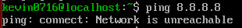
For be sure I run the command ping 8.8.8.8 , and I get the same result.
For check the permission of my machine I run the ls command and the sudo command.
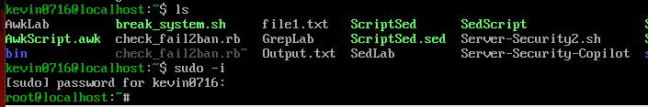
I can use the command, so I have permissions.
For keep checking what else it can be breaking I going to run the command Ip a to check the Ip
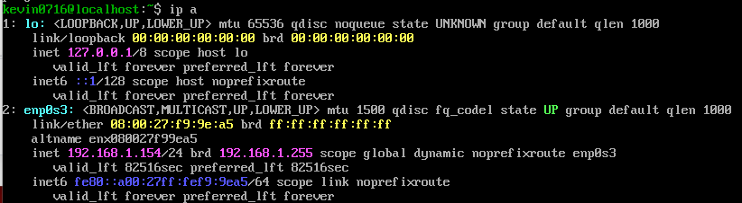
My Ip address is good, so this is not broken.
Now I run the command df -h to check the storage use and if something is going bad in the machine, for this we need to check the Use% column and the “/” symbol that have the partion of the storage.
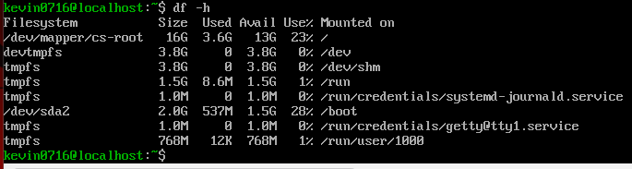
The storage is good, so we do not need to be worried about that now.
If we have something wrong with the storage, we can track the problem with the command du -sh /var/log/* /tmp/* | sort -h to check which files are taking to much space, if something is bad you going to find a file with the name /var/log/bigfile or /tmp/hugefile.
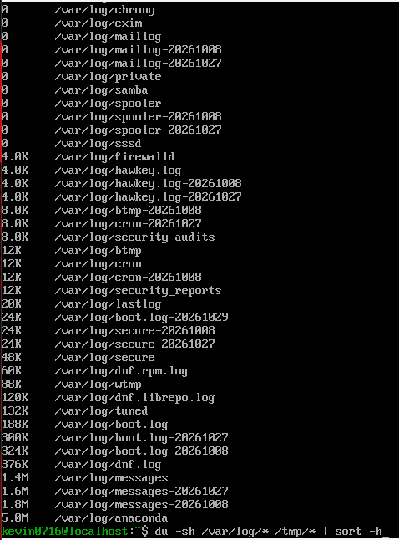
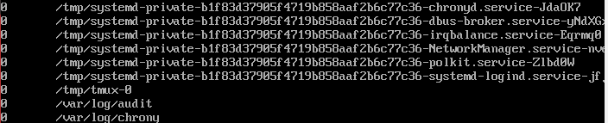
In this case I don’t have anything similar like these files.
Now to fix the problem that I have with my ping command, I need to run the command sudo nmcli connection modify enp0s3 ipv4.method auto. With this command we use a DHCP automatic IP.
After we run the command sudo nmcli connection down enp0s3 && sudo nmcli connection up enp0s3. This command is for reloading the connection,
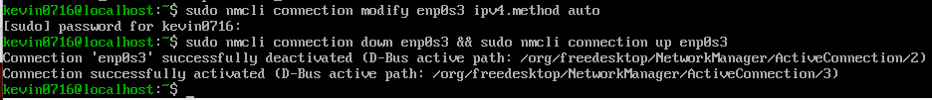
Now I try to ping again a public address, with the command ping google.com .
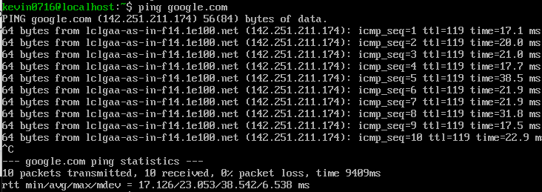
So, the command solves the problem of the ping issue.
For running the script, we are going to use the command sudo .Check-script.sh, we run it in sudo mode because the script needs permission to run, and the results go to the /tmp/system_diagnostic.txt.
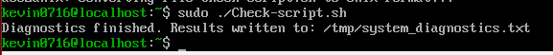

Check-script.sh
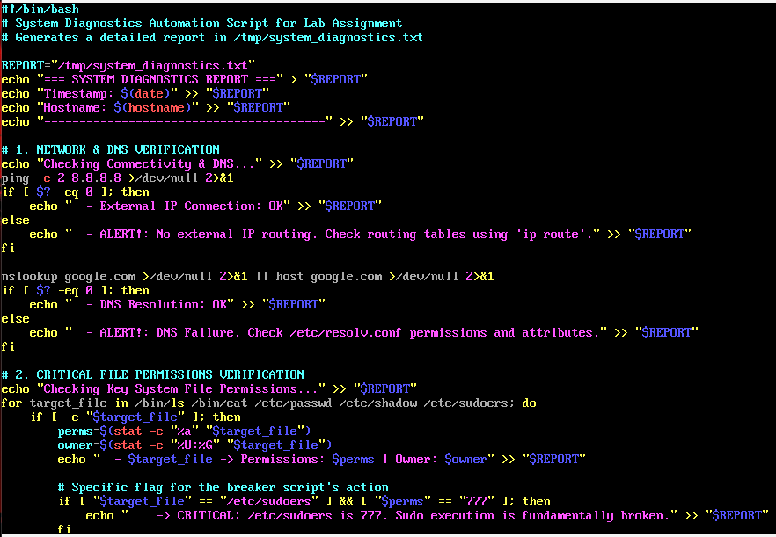

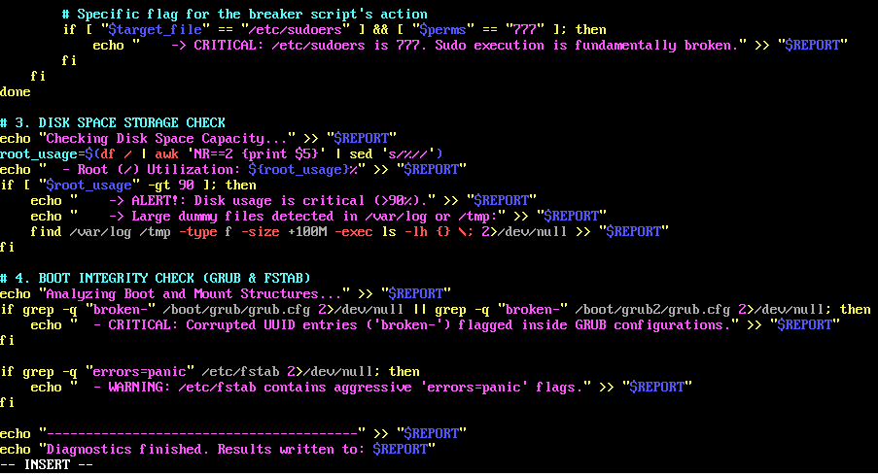
Now we check the file to check the result of the script.
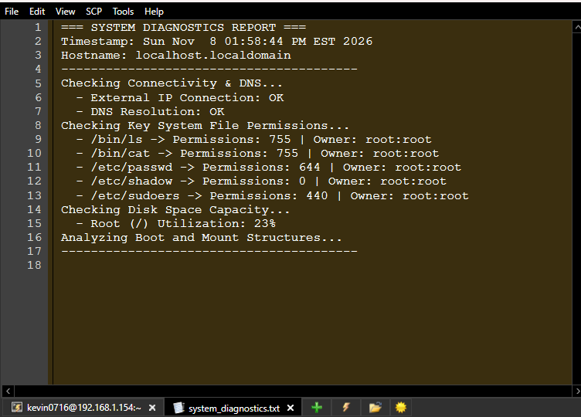
Now for make the cron job, for check the system without broke the system or checking by me every day, we run the in-root mode the command sudo crontab -e, assuming you save the file in /usr/local/bin/ the command is 0 1 * * * /usr/local/bin/Check-script.sh > /dev/null 2>&1.
This configuration is daily because these types of failures like full storage, infinity logs, wrong applications, or permission change can occur in daily production. Executing at 1:00 AM ( 01 **) is better for the charge of the server, minimizing the impact of the production.
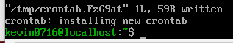
5. Booting into Emergency Mode (emergency.target) is a critical, absolute minimal operational framework used by administrators as an analytical tool of last resort. Unlike standard rescue modes, Emergency Mode boots the system by executing the Linux kernel with the absolute essentials: the root filesystem (/) is mounted strictly as read-only, networking run levels are completely disabled, and systemd avoids reading downstream disk points assigned in /etc/fstab. This mode is indispensable for resolving system boot stalls, structural failures within the GRUB environment, file mapping errors on core configuration blocks, or storage mounting loops preventing normal target completion.
Step 1: Access the GRUB Boot Selection Display
Reboot or power up the guest virtual machine.
Now we need to hit the Esc key repeatedly (on CentOS environments) to trap the system initialization thread and call up the primary GRUB selection screen.
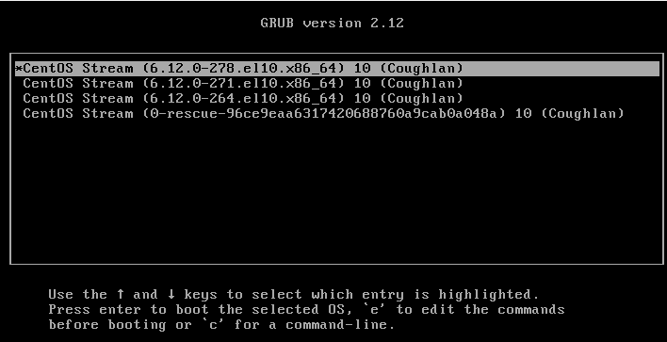

Step 2: Access Parameter Code Modifications
Utilize the directional arrow keyboard options to emphasize and select your principal operational Linux distribution kernel.
Press the e key on the terminal keyboard to suspend automatic execution and open the localized script editor module interface.
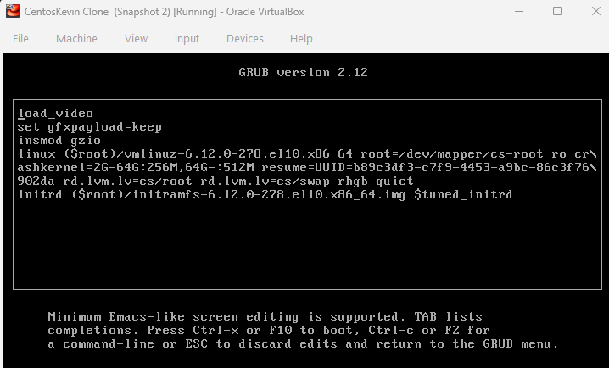
Step 3: Insert the Target Runlevel Parameter Rule
Navigate downwards using the arrow keys to locate the configuration argument instruction line starting with the word keyword linux or linux16 (this sequence contains system commands like ro, quiet, splash, or rhgb quiet).
Position the system terminal text typing cursor at the terminal tail end of this particular code line, hit the spacebar key once, and insert the specific string parameter: systemd.unit=emergency.target
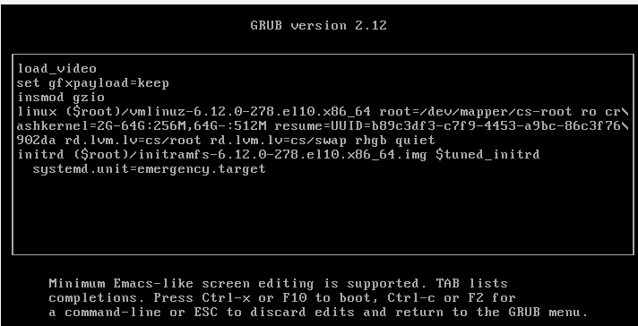
Step 4: Direct System Execution Init Run
Execute the configuration change instructions globally by pressing Ctrl + X or hitting the F10 functional command option key on your keyboard.
The deployment architecture will skip typical loading services, displaying a command screen prompting for administrative authorization codes.
Supply your master administrative root user passphrase credentials to gain an execution prompt interface.
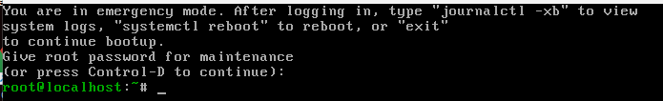
Step 5: Remount the Filesystem Layer to Apply Changes
Because the underlying target host file structural volume layout locks into read-only parameters upon entering this state by safety default, execute the following script command to unlock editing features before attempting to rewrite configuration parameters (such as repairing a broken /etc/fstab file): mount -o remount,rw /
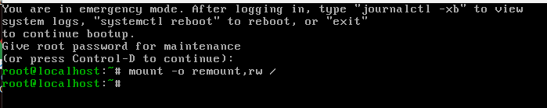
After that we run the command reboot, and we repair the problem and get.
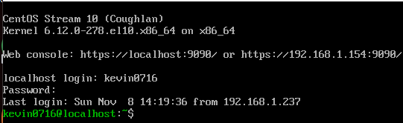

GitHub: https://github.com/kevinNunez137/Linux-Administration

References:
https://www.aholdengouveia.name/LinuxAdmin/serversecurity.html
youtube.com/watch?v=s5uw5BiKehg&time_continue=3&source_ve_path=MjM4NTE&embeds_referring_euri=https%3A%2F%2Fnecc.brightspace.com%2F
https://web.archive.org/web/20220607232203/https://www.networkworld.com/article/3330497/linux-commands-for-measuring-disk-activity.html
https://web.archive.org/web/20221012133324/https://www.linuxfoundation.org/blog/blog/classic-sysadmin-linux-101-5-commands-for-checking-memory-usage-in-linux
https://web.archive.org/web/20220510004952/https://www.networkworld.com/article/3428361/how-to-manage-logs-in-linux.html
https://ncp.nist.gov/repository
https://www.freedesktop.org/software/systemd/man/systemd.special.html
https://man7.org/linux/man-pages/man5/crontab.5.html
https://man7.org/linux/man-pages/man5/fstab.5.html
https://ubuntu.com/server/docs/explanation/networking/configuring-networks/
https://docs.centos.org/
https://docs.redhat.com/en/documentation/red_hat_enterprise_linux/6/html/deployment_guide/sec-emergency_mode
https://www.gnu.org/software/bash/manual/bash.html
https://www.gnu.org/software/coreutils/manual/coreutils.html

